* Project Requirements (Jakob)
  + Functional:
    - Provide helpful hints about the course based on the location of the player.
    - System shall allow players to login and register their device
    - Players app displays progress on the course, playing time, Warnings about playing speed, and request to allow playthrough.
    - Players can view player history and dashboard
    - Players login and register at golf ranges
  + Non-functional:
    - Downloadable application from standard stores
    - Track players position on a virtual golf course utilizing an application on the players phones that transmits GPS location information; possibly using geo-fencing for more accurate location data.
    - The system shall track in real time
    - System shall monitor player behavior and provide a player dashboard.
    - Software should be portable
* Project Plan (Quentin)
  + 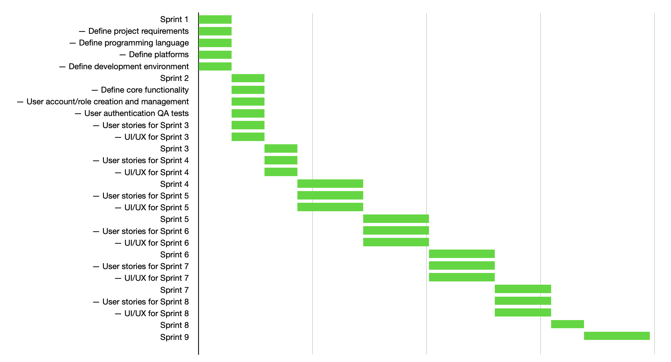
* Tool Chain (Collin)
  + Native Mobile App (Android): Android Studio
  + Native Mobile App (iOS): Swift > XCode
  + Web App: IDE\*,
  + Server: IDE\* > GCP or AWS
* Language (Collin)
  + Frontend: HTML5, JS/TypeScript
  + Backend: Python, JS
  + Framework: JSON, jQuery, Bootstrap, Angular or React
* Config. Management (Travis) \*
  + Kubernetes, Puppet, Ansible, Terraform, Docker, etc.
* Server Setup (Dustin)
  + If creating a web application: LAMP stack(Could use a different database and language), Bitnami, etc.
    - Requires a host server that can be connected to remotely.
    - Virtual machines on public platforms (GCP, AWS, etc) mostly require money to use the services.
    - Could apply for a virtual machine from Oakland University which only requires VPN connection.
* Development environment, etc. (Luis)
  + IDE, Github, debugging tools, etc.
    - Visual Studio -> free, only available for windows open source comes with a debugging tool

Supports -> Python, HTML, CSS, Javascript, PHP, Sass. Node.js, Typescript

* + - Atom-> free, allows for real time collaboration on code, easy to use with Github

Supports -> HTML, Java, JavaScript, JSON, Python, PHP, SQL, CSS, Node.js

* + - Eclipse-> free cross platform, mostly centered around Java

Supports -> Python, Javascript, PHP, Java, Node.js

* + - Komodo ->Comes with Debugging/Unit Testing, free, available cross platform.

Supports -> HTML, CSS, Python, Node.js, Javascript, PHP, Sass